Exercise: Nested Loops and Methods
Test your tasks in the Judge system: https://judge.softuni.org/Contests/4422

Nested Loops

Stupid Passwords
Write a program that:
- Reads an integer number N from the console
- Generates all possible passwords consisting of the following 3 parts:
  - The first part is an even number in the range [2…N]
  - The second digit is an odd number in the range [1…N]
  - The third is the product of the first two
- The output holds all possible passwords
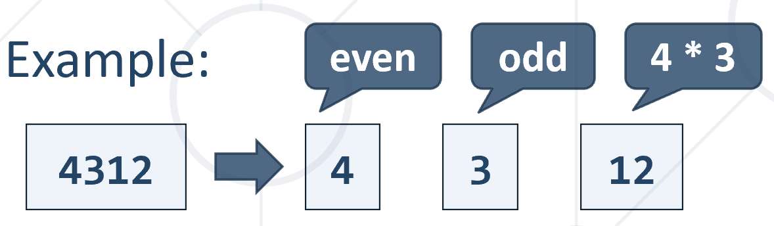

Example
Input | Output
11 | 212 236 2510 2714 2918 21122 414 4312 4520 4728 4936 41144 616 6318 6530 6742 6954 61166 818 8324 8540 8756 8972 81188 10110 10330 10550 10770 10990 1011110
5 | 212 236 2510 414 4312 4520
6 | 212 236 2510 414 4312 4520 616 6318 6530

Magic Numbers
Write a program that:
- Reads an integer number N from the console
- Find all 3-digit magic numbers

Note: A magic number is a three-digit number where the product of its digits equals the value of N. If you have a three-digit number abc, where a, b and c are its digits, it is considered a magic number of order N, if a * b * c = N.

Example
Input | Output |  | Input | Output |  | Input | Output
1 | 111 |  | 3 | 113 131 311 |  | 7 | 117 171 711

Unique PIN Codes
Write a program to generate PIN codes following certain rules:
  - Read 3 integer digits: max1, max2, max3 (each is an upper limit)
  - Generate unique 3-digit PIN codes, matching the following:
  - Each digit is within the following range:
    - First digit: [1 … max1]
    - Second digit: [1 … max2]
    - Third digit: [1 … max3]
  - The first and the third digit must be even
  - The second digit must be a prime number in the range [2…7]
  - Print the PIN codes, each on separate line

Example
Input | Output |  | Input | Output |  | Input | Output
3  5  5 | 222  224  232  234  252  254 |  | 4  4  6 | 222  224  226  232  234  236  422  424  426  432  434  436 |  | 3  3  5 | 222  224  232  234

Letter Combinations
Write a program to generate 3-letter combinations under certain conditions:
  - Read a start letter s, end letter e and excluded letter x
  - Generate all combinations of 3 letters in the range [s…e], excluding x
  - Print all combinations on the first line
  - Print combinations count on the second line

Example
Input | Output
a  c  b | aaa aac aca acc caa cac cca ccc  8

Input | Output
d  g  e | ddd ddf ddg dfd dff dfg dgd dgf dgg fdd fdf fdg ffd fff ffg fgd fgf fgg gdd gdf gdg gfd gff gfg ggd ggf ggg  27

Happy Numbers
Write a program that:
- Reads an integer number N from the console
- Generate all 4-digit happy numbers {d1}{d2}{d3}{d4} for given integer N:
  - A number is happy if d1 + d2 == d3 + d4 == N
  - Print all happy numbers

Example
Input | Output
3 | 1203 1212 1221 1230 2103 2112 2121 2130 3003 3012 3021 3030
4 | 1304 1313 1322 1331 1340 2204 2213 2222 2231 2240 3104 3113 3122 3131 3140 4004 4013 4022 4031 4040

Methods

Vowels Count
Write a program that:
- Read a text (string) from the console
- Create a method that receives a text
- Find the count of the vowels contained in the text
- Print the count of the vowels in the text

Example
Input | Output
SoftUni | 3
Cats | 1
JS | 0

Factorial Division
Write a program that:
- Read two integers numbers from the console in range [1…10]
- Calculate the factorial of each number
- Divide the first calculated factorial by the second calculated factorial (integer division)
- Print the result of the division

Example
Input | Output |  | Input | Output
5  2 | 60 |  | 6  2 | 360

Multiplication Sign
Write a program that:
- Reads three integer numbers (num1, num2 and num3) from the console
- Finds if num1 * num2 * num3 (the product) is negative, positive or zero
- Print:
  - negative - if the product is smaller than 0
  - positive - if the product is bigger than 0
  - zero - if the product is equals to 0
Note: Try to do this WITHOUT multiplying the three numbers.

Example
Input | Output |  | Input | Output |  | Input | Output
2  3  -1 | negative |  | 2  3  1 | positive |  | 7  0  1 | zero

Password Validator
Write a program that checks if a given password is valid.
The password validation rules are:
- It should contain 6 – 10 characters (inclusive)
- It should contain only letters and digits
- It should contain at least 2 digits
If it is not valid, for any unfulfilled rule print the corresponding message:
- "Password must be between 6 and 10 characters"
- "Password must consist only of letters and digits"
- "Password must have at least 2 digits"

Exaзmple
Input | Output
logIn | Password must be between 6 and 10 characters  Password must have at least 2 digits
MyPass123 | Password is valid
Pa$s$s | Password must consist only of letters and digits  Password must have at least 2 digits

